(Design Guide)

h



GROUP MEMBERS:

|  |  |
| --- | --- |
| **Hooria Shireen** | **Student1618603** |
| **Tehzeeb Fatima** | **Student1618869** |
| **Hooria** | **Student1620919** |

**ACCPAI**



CURRICULUM:

**CPISM**



SEMESTER:

**Sir Maaz Rahim Khan**



FACULTY: s ss



CERTIFICATE OF RECOGNITION:

This certificate is awarded to acknowledge the exceptional efforts and dedication demonstrated in the successful completion of the eProject titled:

**Project Name: London bakers and sweets**

as part of the **First Semester** in **Course Name**:ACCPAI

This recognition highlights the creativity, problem-solving abilities, and teamwork that contributed to the project's success. Your commitment to excellence and innovation has set a benchmark for your peers, reflecting your strong passion for learning and development.

Your contributions not only showcase technical proficiency but also emphasize collaboration, critical thinking, and a proactive approach toward achieving goals.

**Presented On: 20-March-2025**

**FACULTY: Sir Maaz Rahim Khan**

**Acknowledgment**

We sincerely thank everyone who helped make this project a success.

A special thanks to **Mentor/Instructor’s Name** for their valuable guidance and support throughout the process.

We are also grateful to our team members for their hard work, dedication, and teamwork, which made this project possible.

Our heartfelt appreciation goes to our families for their love and support, keeping us motivated along the way.

Lastly, we thank everyone who provided us with the resources and opportunities needed to complete this project.



PROBLEM STATEMENT:

In this project, we faced issues linking each other’s work and also had problems with navbar , otherwise there were no other issues.

# Requirement Specification:

**# londonbakers**

The ‘London Bakers and Sweets’ is a Sweets and Bakery Items shop. It provides

wide variety of products.

The site provides list of products along with the Ingredient and Nutrition details.

Consumers can select and choose from the wide range of products

‘London Bakers and Sweets’ is looking to restructure the entire website to provide

information and also connect with prospective customers.

Requirement Specification:

The Web site is to be created based on the following requirements.

1) The Home Page should be created with proper sections, graphics and with a

suitable logo

2) The site should display a menu with following categories:

• About Us

• Products – Sweets

• Products – Bakery

• Gift Hampers

• Contact Us

3) Products should be accompanied with the details, Nutrition value and

Ingredient details.

4) It should also be accompanied with Price in DOLLAR [$] and Weight.

5) Gift Hamper should provide details about the gift items and price with weight.

6) ‘About Us’ should provide details of the company and past and upcoming

events.

7) There should be a “Contact Us” page which will have the Address of the

Company which is as follows and the mail address which when clicked will

invoke the local mail client from where they can send an email.





SITE MAP:

***HOME***

***Contact Usct us***

***OUR***

***Bakery***

***About Us***

Categories

***Bakery***

Cakes

Nimko

***Homepageppage oage***

Ice Cream

***Gifts***

Halwajat

Donuts

***Sweets***





Checklist Of Validation:

|  |  |
| --- | --- |
| **Option** | **Validation** |
| **Do all text links lead to the appropriate web pages?** | **YES** |
| **Do all the image links lead to the appropriate web pages?** | **YES** |
| **Are all images and links clearly visible in web pages?** | **YES** |
| **Is web page opening properly in all tested web browsers?** | **YES** |
| **Are animations loading well?** | **YES** |
| **Is the website responsive?** | **YES** |
| **Is website taking too long to load?** | **NO** |
| **Is the navigation sequence correct through all the webpages on the site?** | **YES** |
| **Is the JavaScript code working as expected in all click events?** | **YES** |



Task Sheet:

|  |  |  |  |  |  |
| --- | --- | --- | --- | --- | --- |
| S  No. | TASK | Member Name | Start Date | Days Used | Status |
| 1 | Home | Hooria Shireen | 25-march2025 | 5 | COMPLETE |
| 2 | About Us | Hooria Shireen, Tehzeeb Fatima | 30-march-2025 | 5 | COMPLETE |
| 3 | Bakery | Tehzeeb Fatima | 3rd-april-2025 | 10 | COMPLETE |
| 4 | Gifts | Tehzeeb Fatima | 5th-april-2025 | 1 | COMPLETE |
| 6 | Sweets | Tehzeeb Fatima | 7th-april-2025 | 2 | COMPLETE |
| 7 | Contact Us | Hooria Shireen | 10th-april-2025 | 2 | COMPLETE |
| 8 | Categories | Hooria | 12th-april-2025 | 4 | COMPLETE |



**NAVBAR:**

It is used to navigate from one page to other within the website.

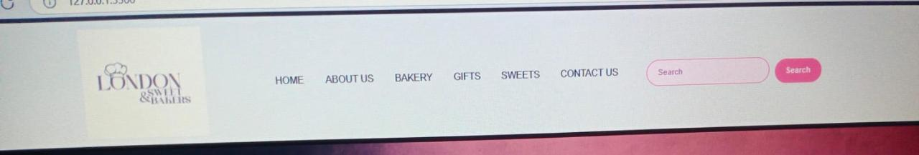

**CAROUSEL:**

It is used for display of multiple images in a single plane.

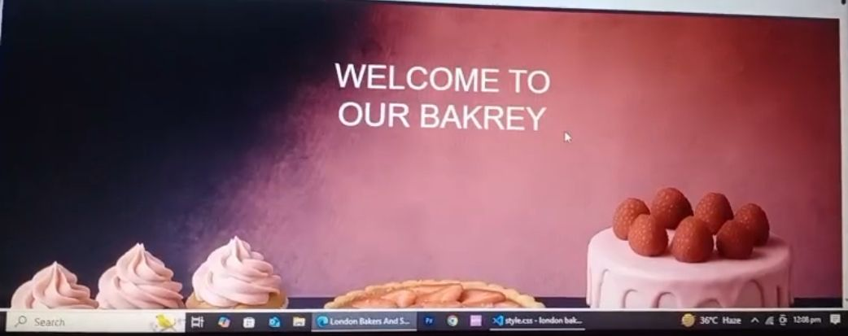

**Bakery:**

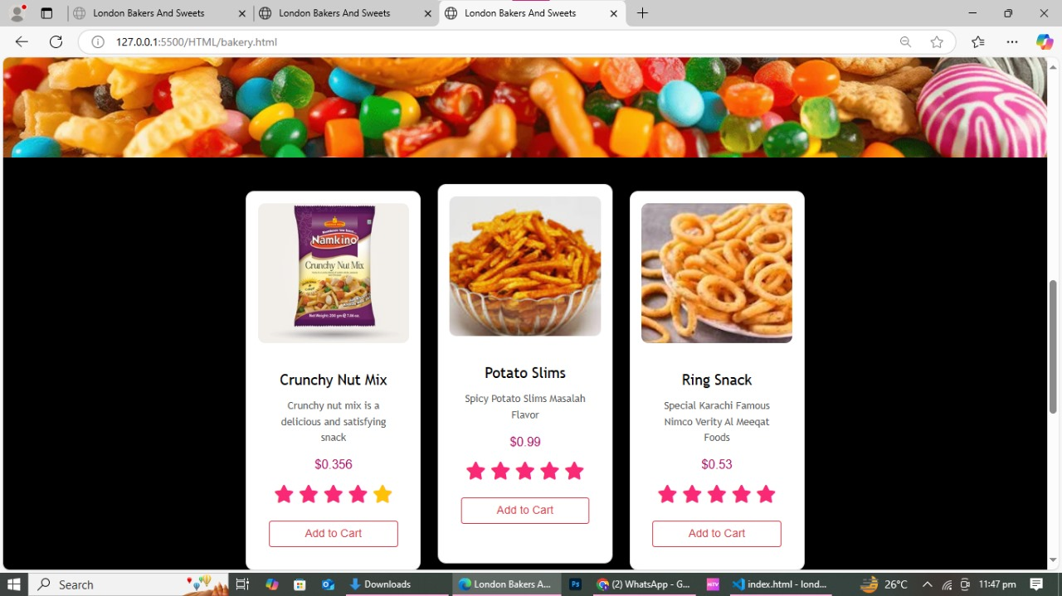

 **Gifts:**

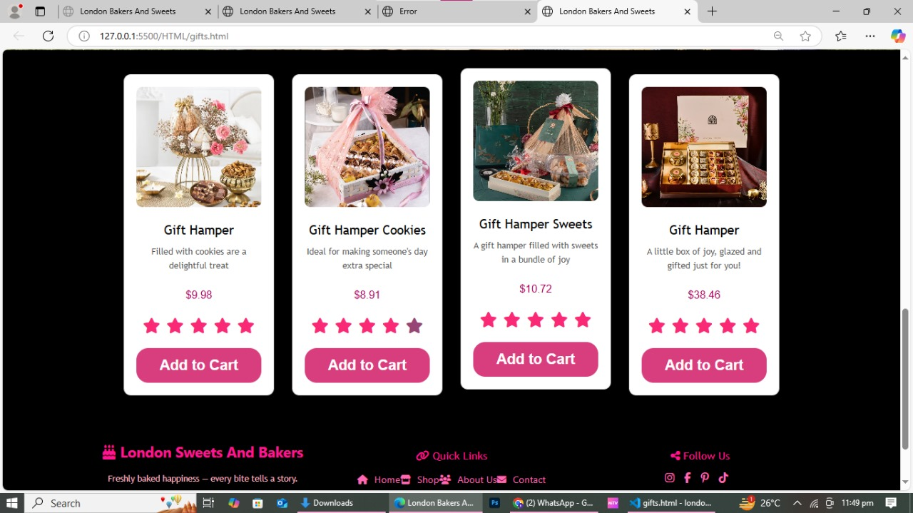

**Sweets:**

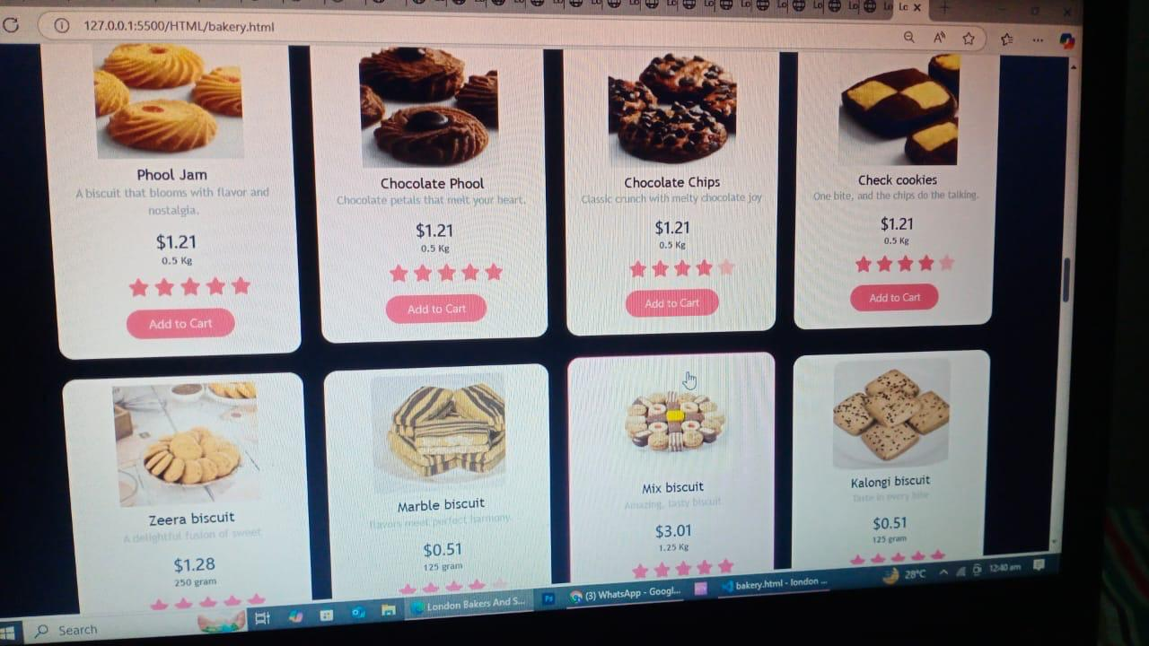

 **Contact Us:**

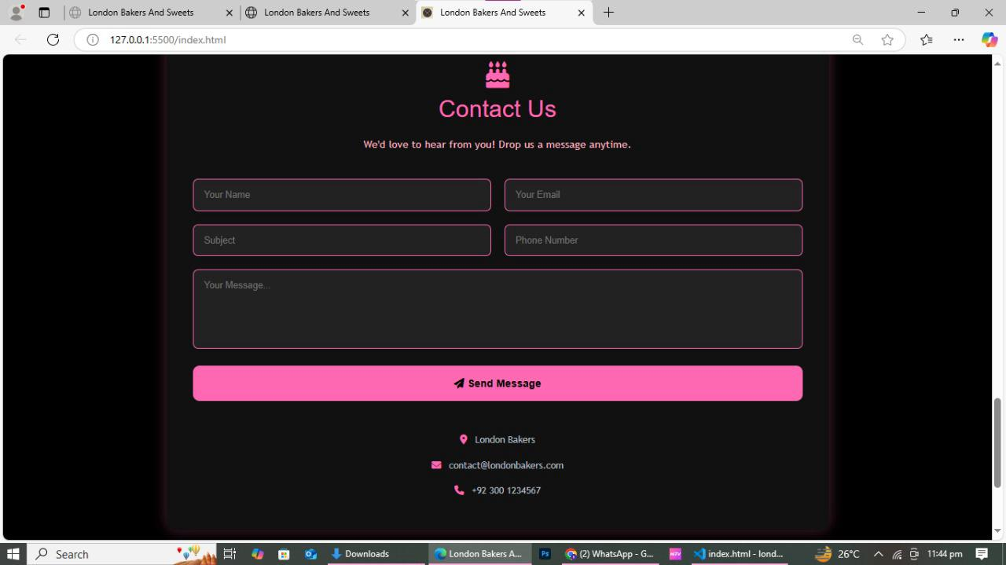

**Categories:**

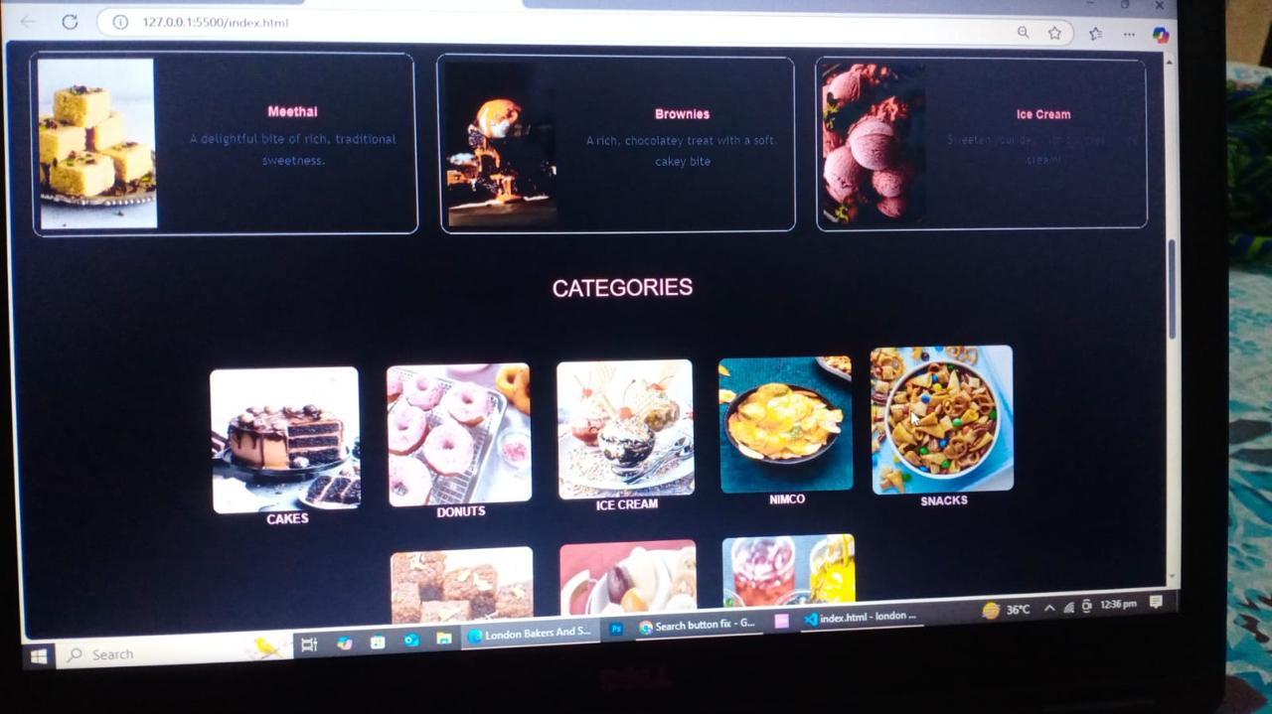

** Cakes:**

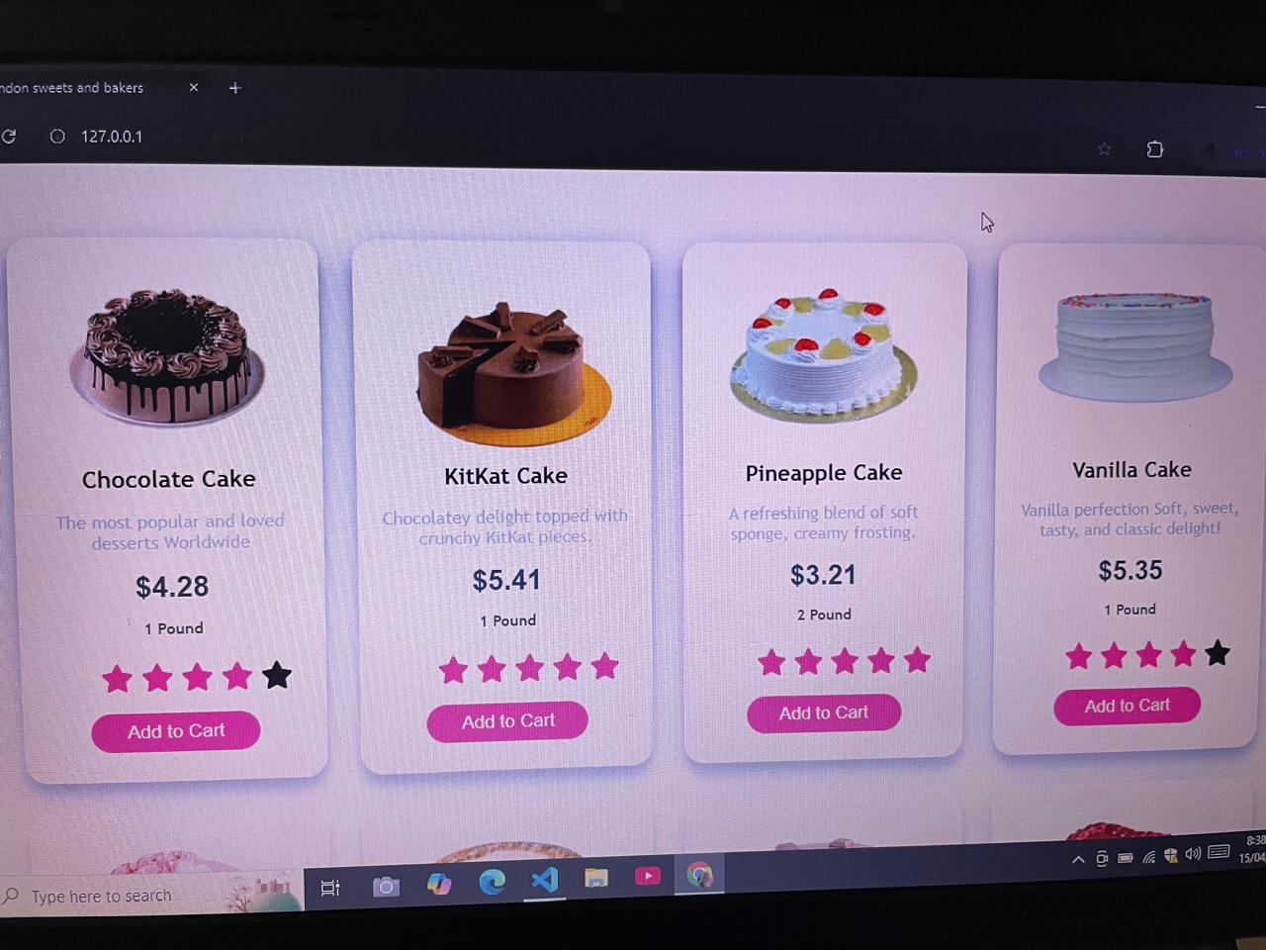

** Nimko:**

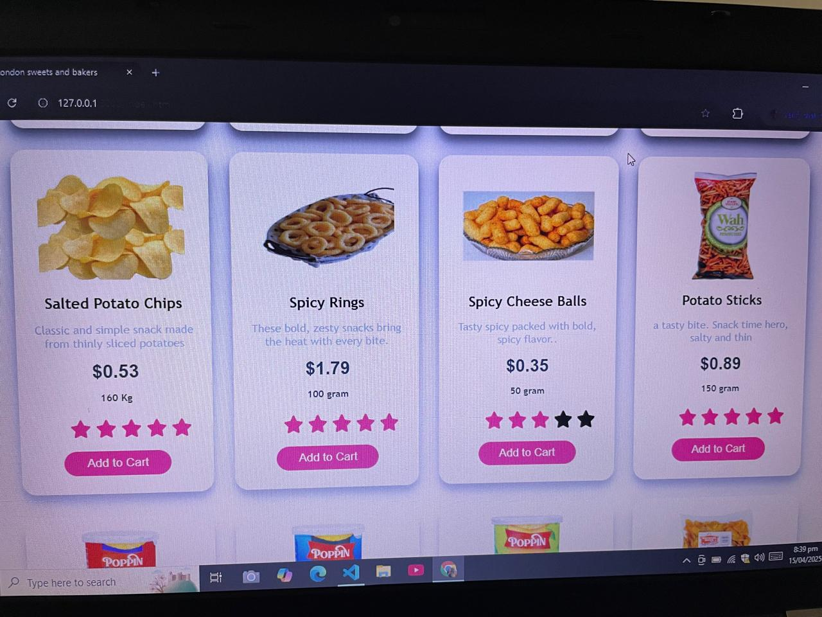

**Ice Cream:**

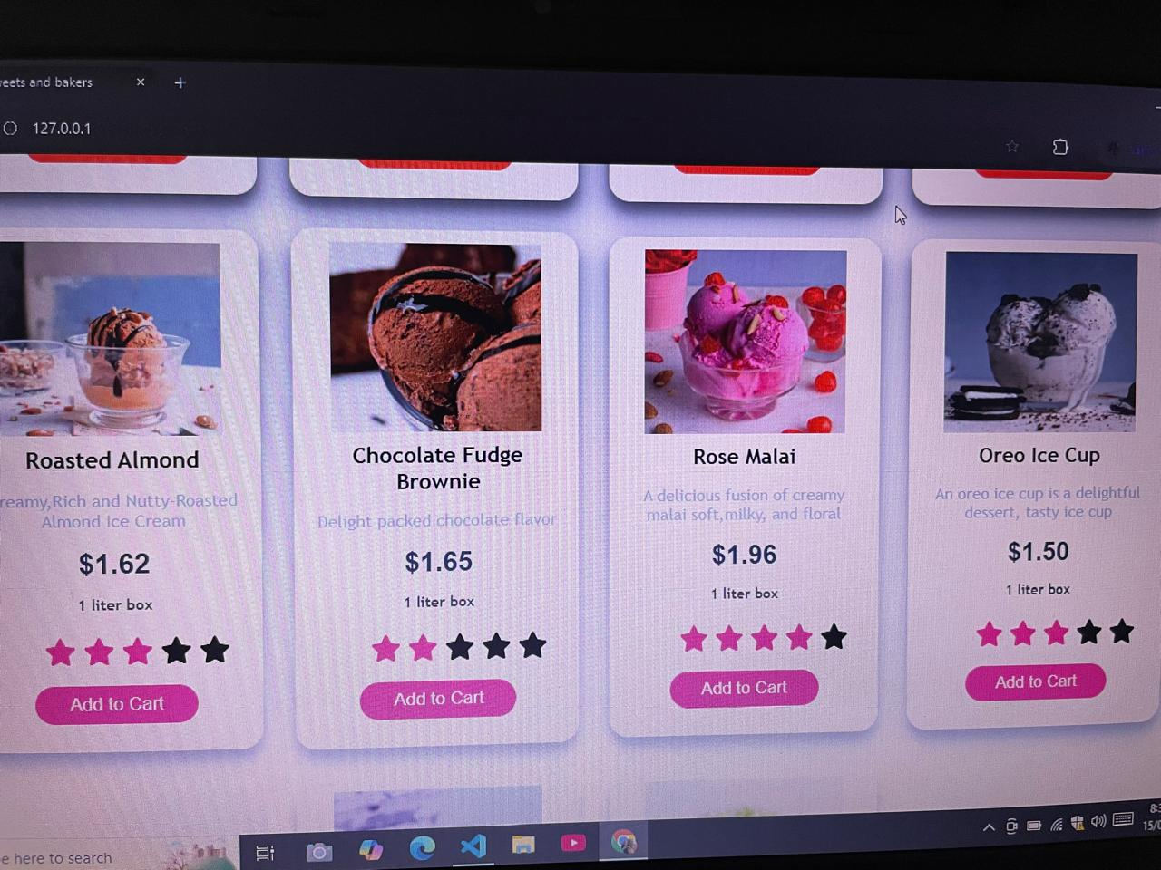

 **Halwajat:**

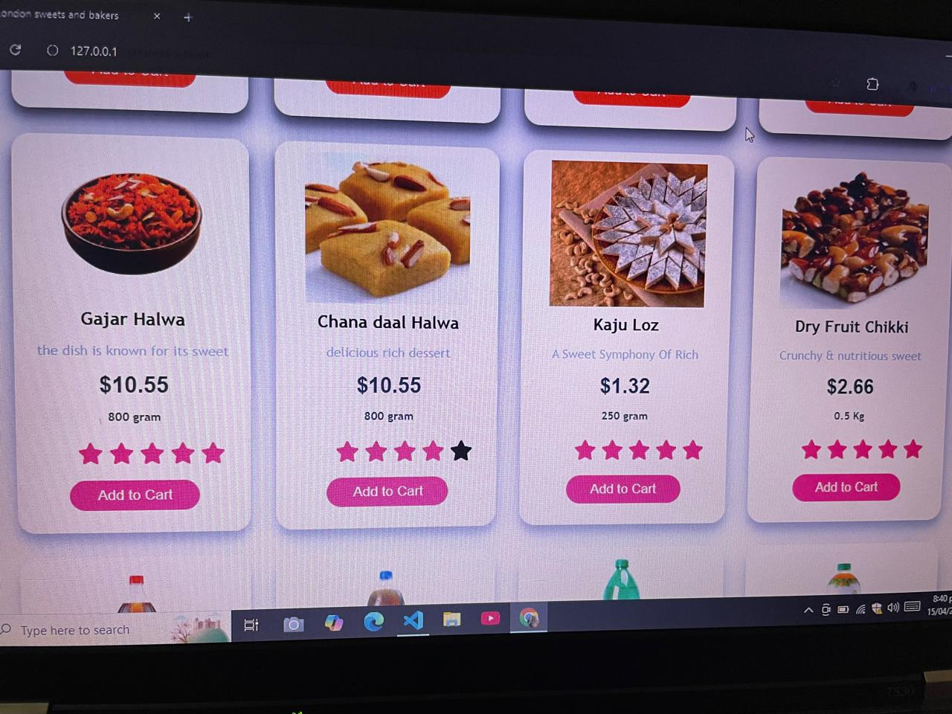

 **Donuts:**

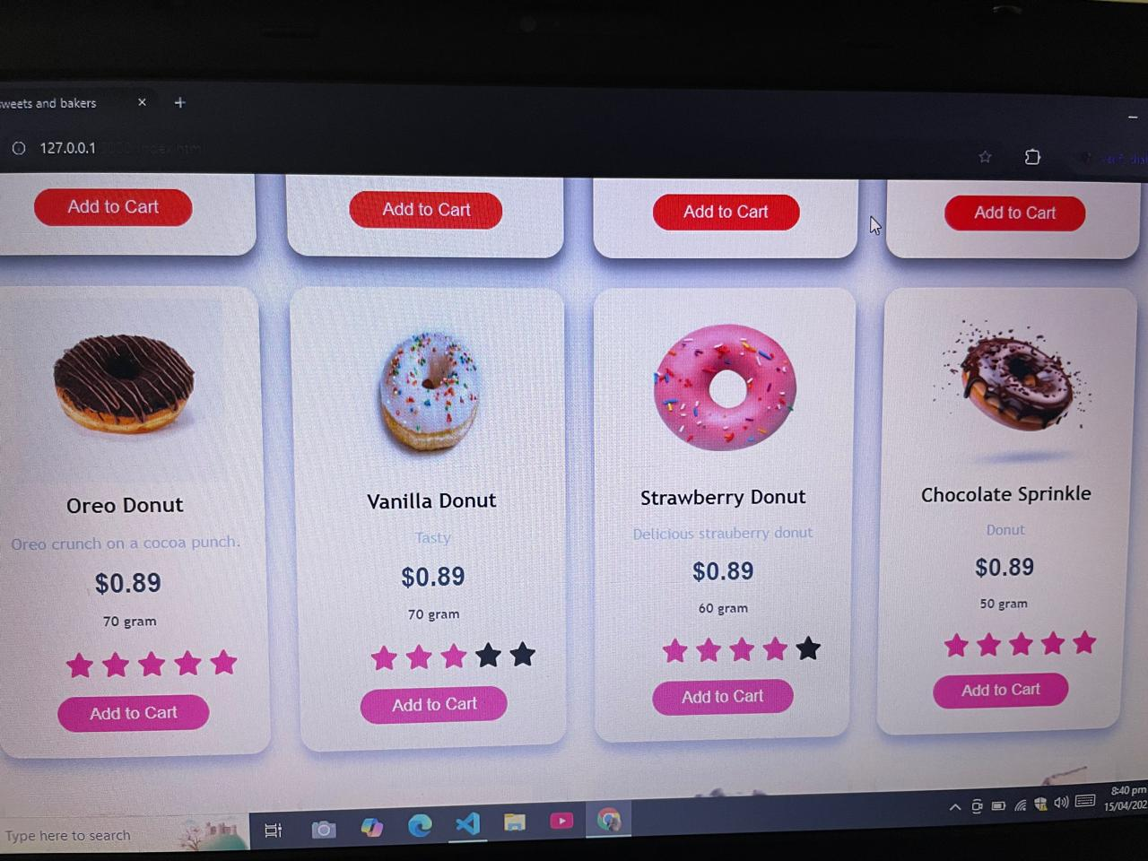

**Home Page :**

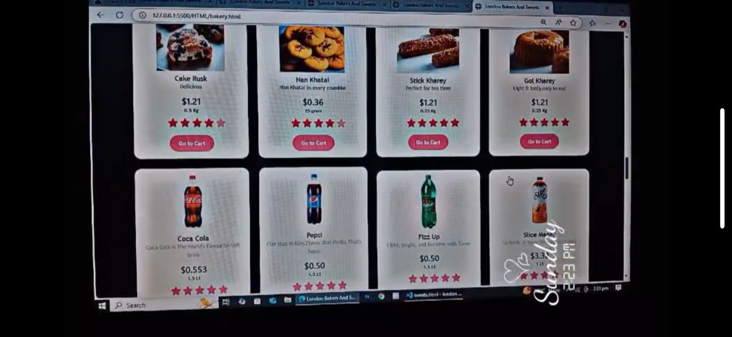

**Footer:**











